**Aim:** Understanding Decision Making Statements using R

**IDE:** R Studio

**Theory:**

Decision making is about deciding the order of execution of statements based on certain conditions. In decision making programmer needs to provide some condition which is evaluated by the program, along with it there also provided some statements which are executed if the condition is true and optionally other statements if the condition is evaluated to be false.

The decision making statement in [R](https://www.geeksforgeeks.org/introduction-to-r-programming-language/) are as followed:

* [if statement](https://www.geeksforgeeks.org/decision-making-in-r-programming-if-if-else-if-else-if-ladder-nested-if-else-and-switch/#if)
* [if-else statement](https://www.geeksforgeeks.org/decision-making-in-r-programming-if-if-else-if-else-if-ladder-nested-if-else-and-switch/#if-else)
* [if-else-if ladder](https://www.geeksforgeeks.org/decision-making-in-r-programming-if-if-else-if-else-if-ladder-nested-if-else-and-switch/#if-else-if)
* [nested if-else statement](https://www.geeksforgeeks.org/decision-making-in-r-programming-if-if-else-if-else-if-ladder-nested-if-else-and-switch/#nested)
* [switch statement](https://www.geeksforgeeks.org/decision-making-in-r-programming-if-if-else-if-else-if-ladder-nested-if-else-and-switch/#switch)

#### **if statement**

Keyword [**if**](https://www.geeksforgeeks.org/r-if-statement/)tells compiler that this is a decision control instruction and the condition following the keyword if is always enclosed within a pair of parentheses. If the condition is TRUE the statement gets executed and if condition is FALSE then statement does not get executed.

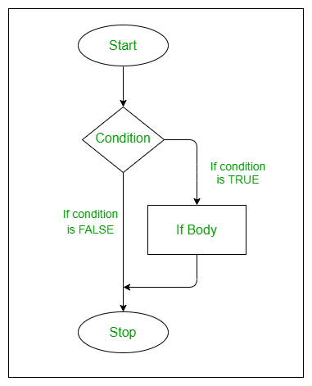

          if(condition is true){

                execute this statement

           }

#### **if-else statement**

[If-else](https://www.geeksforgeeks.org/r-if-else-statement/), provides us with an optional else block which gets executed if the condition for if block is false.  If the condition provided to if block is true then the statement within the if block gets executed, else the statement within the else block gets executed.

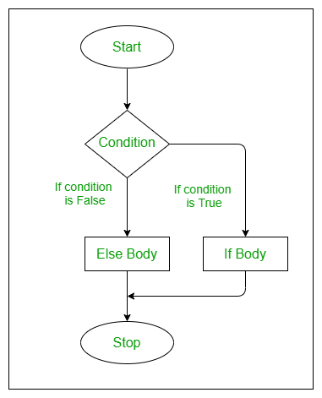

        if(condition is true) {

              execute this statement

          } else {

             execute this statement

          }

#### **if-else-if ladder**

It is similar to if-else statement, here the only difference is that an if statement is attached to else. If the condition provided to if block is true then the statement within the if block gets executed, else-if the another condition provided is checked and if true then the statement within the block gets executed.

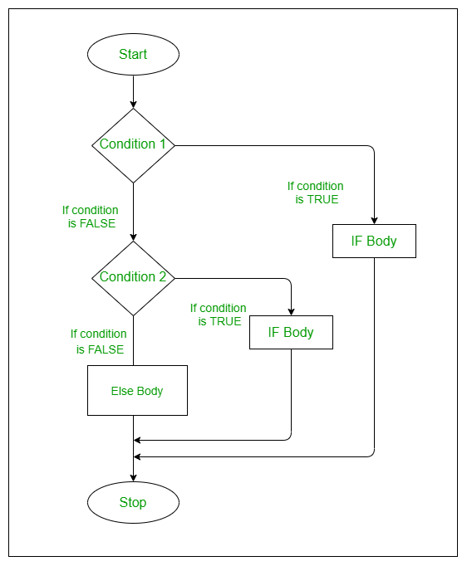

    if(condition 1 is true) {

              execute this statement

         } else if(condition 2 is true) {

             execute this statement

         } else {

             execute this statement

        }

 if(parent condition is true) {

              if( child condition 1 is true) {

                 execute this statement

             } else {

                execute this statement

            }

     } else {

            if(child condition 2 is true) {

                execute this statement

            } else {

               execute this statement

           }

     }

#### **Nested if-else statement**

When we have an if-else block as an statement within an if block or optionally within an else block, then it is called as nested if else statement. When an if condition is true then following child if condition is validated and if the condition is wrong else statement is executed, this happens within parent if condition. If parent if condition is false then else block is executed with also may contain child if else statement.

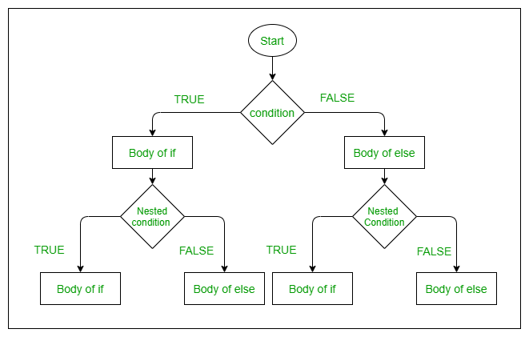

if(parent condition is true) {

              if( child condition 1 is true) {

                 execute this statement

             } else {

                execute this statement

            }

     } else {

            if(child condition 2 is true) {

                execute this statement

            } else {

               execute this statement

           }

     }

#### **switch statement**

In this [switch](https://www.geeksforgeeks.org/switch-case-in-r/) function expression is matched to list of cases. If a match is found then it prints that case’s value. No default case is available here. If no case is matched it outputs NULL as shown in example.

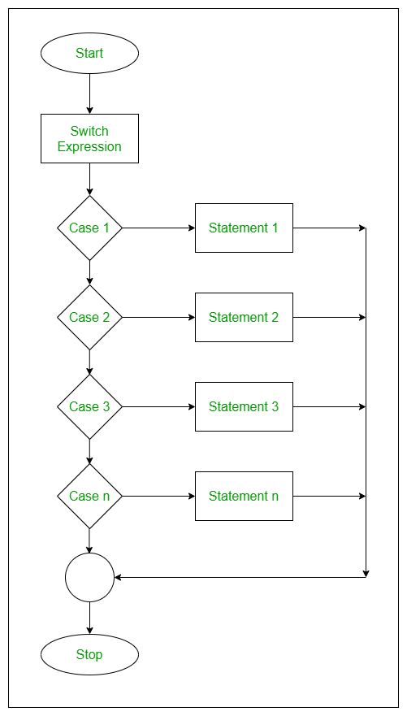

switch (expression, case1, case2, case3,…,case n )

**Programs:**

Write R script that demonstrates the functionality of all the decision making statements:

1. Write a program that interchange or swap the values of 2 variables.
2. Get a character in lower case form user and display it in upper case.
3. Get a character from user and print tell that is it vowel or consonant.
4. Write a program that take input of 5 subjects marks. Count the percentage.

Print the result for following conditions:

If student has 70% or more then 70% then DISTINCTION.

If student has percentage between 60 and 69 then FIRST CLASS.

If student has percentage between 50 and 59 then SECOND CLASS.

If student has percentage between 40 and 49 then PASS CLASS.

If student has percentage less then 40 then FAIL.

1. Write a program that take input of 5 subjects marks. If student get 40 or more then 40 then

he is PASS in that subject otherwise FAIL print the result for following condition:

If student is pass in all subjects then declare PASS.

Is student is fail in 1 or 2 subject then declare ATKT.

If student is fail in more then 2 subject then declare FAIL.

1. Write a program that count the area for circle, square, rectangle and triangle using Switch-

Case control structure

1. Write a program that take input of year in 4 digit. Determine whether the year is leap year

or not

1. Write a program that determine the grade of steel according to following condition:

1 Hardness must be greater then 50

2 Carbon must be less then 0.7

3 Tensile must be greater then 5500

Take the input for above qualities through keyboard from user Grades are decided as follows:

Grade A if all 3 conditions are met.

Grade B if condition (1) and (2) are met.

Grade C if condition (2) and (3) are met.

Grade D if condition (1) and (3) are met.

Grade E if only one condition met.

Grade F if none of conditions are met.

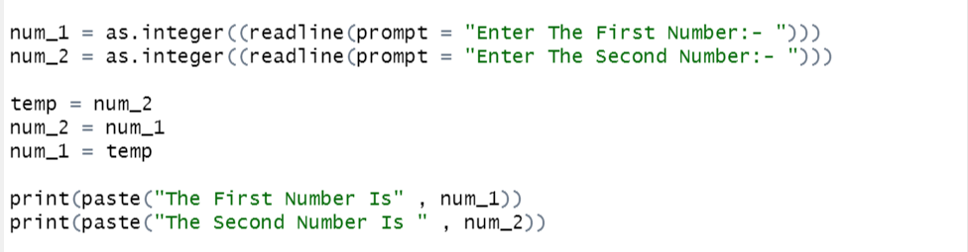

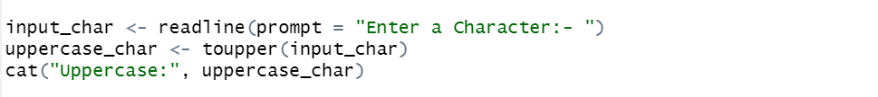

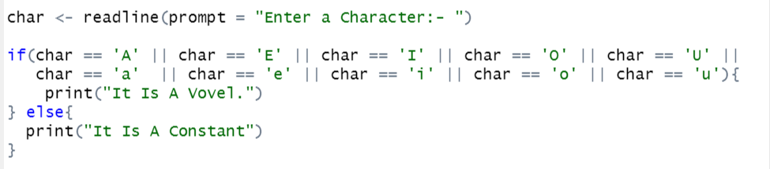

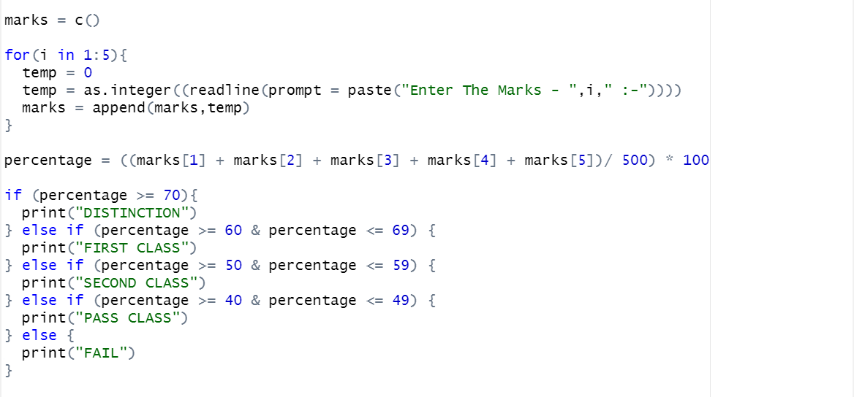

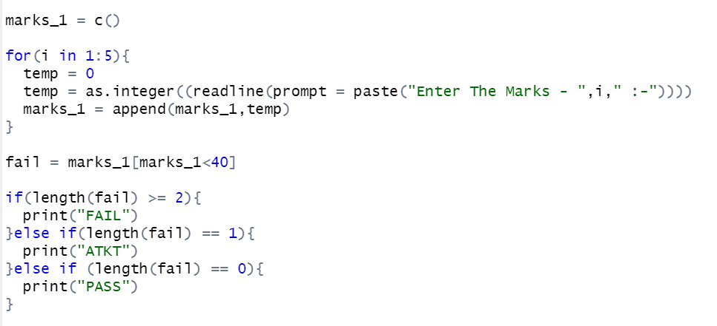

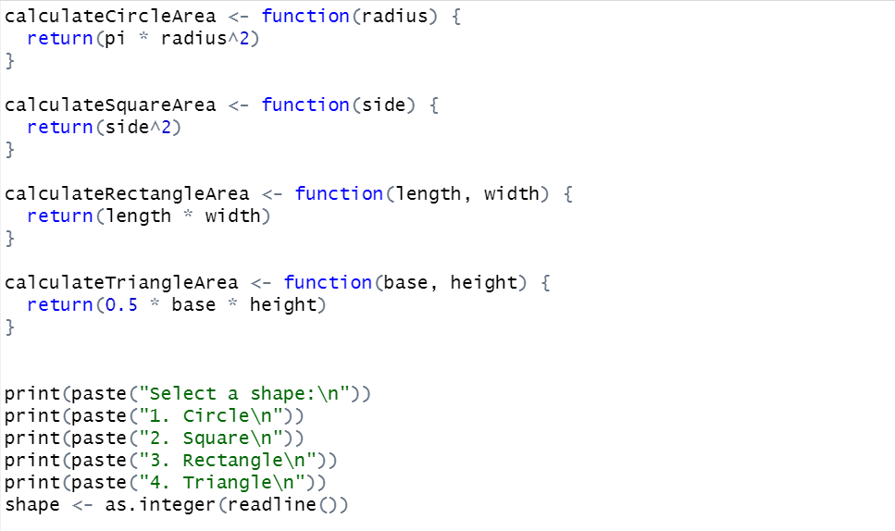

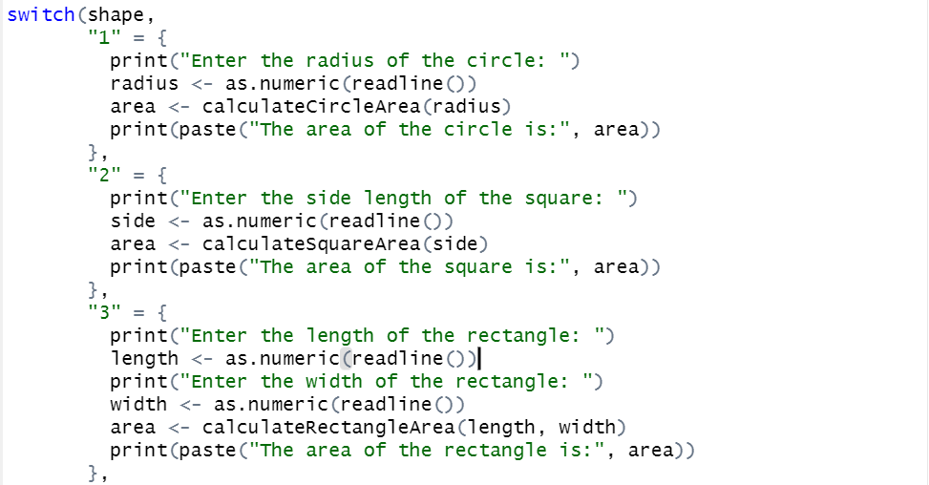

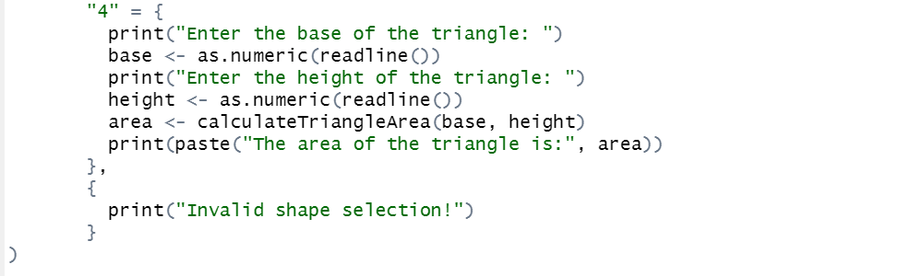

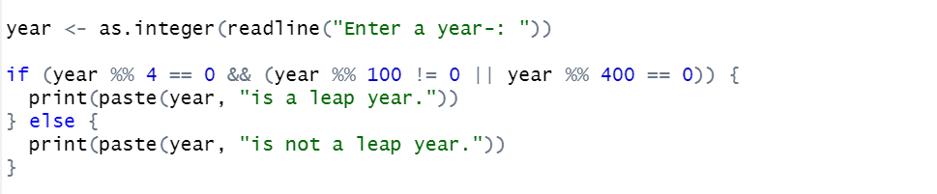

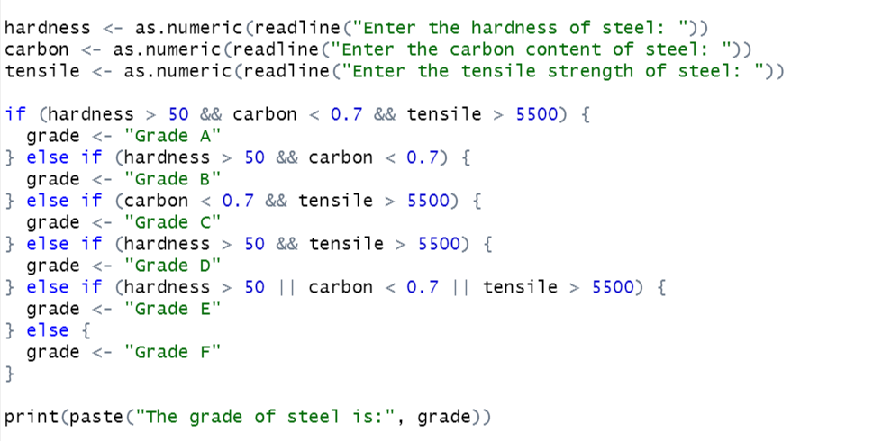

**Output:**

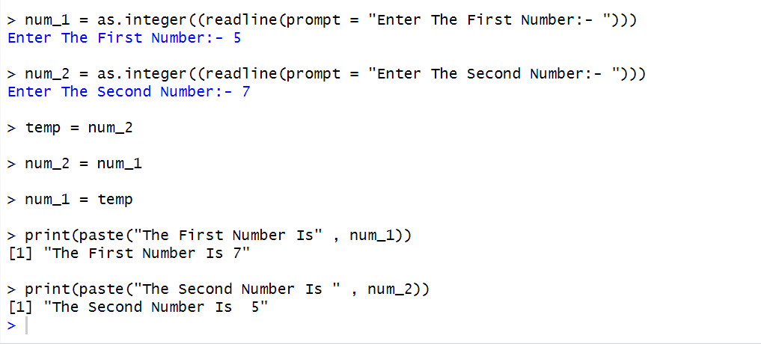

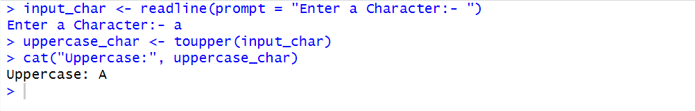

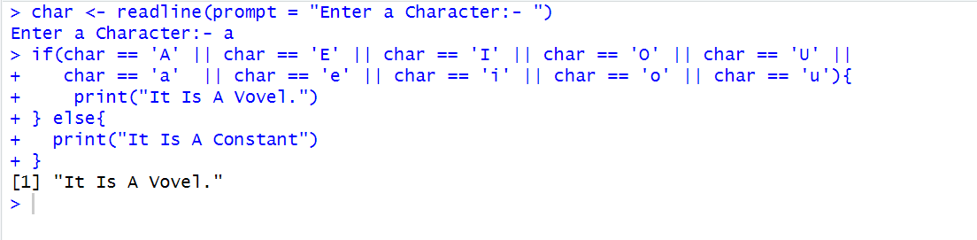

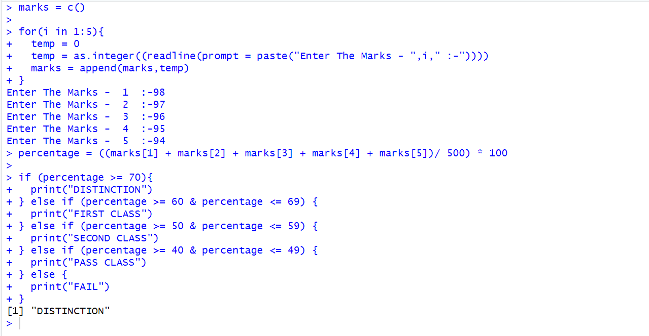

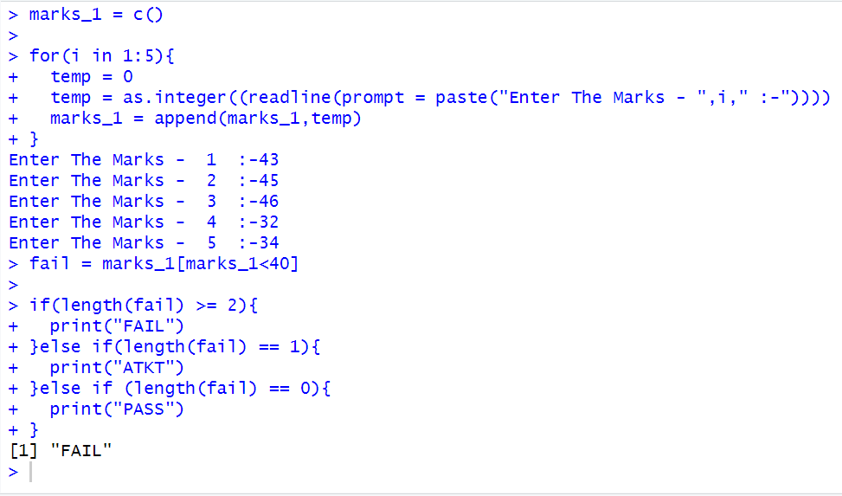

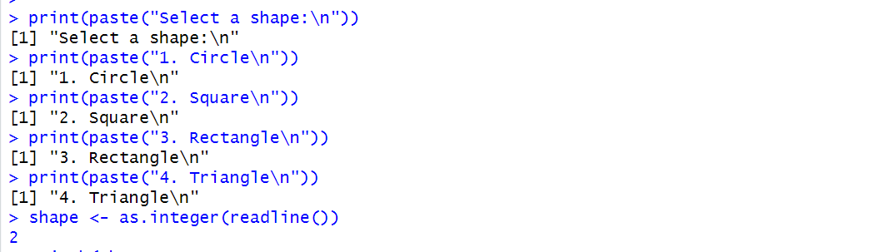

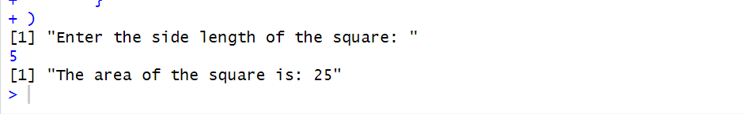

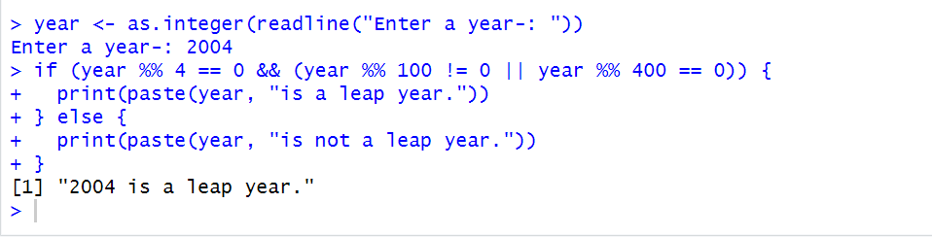

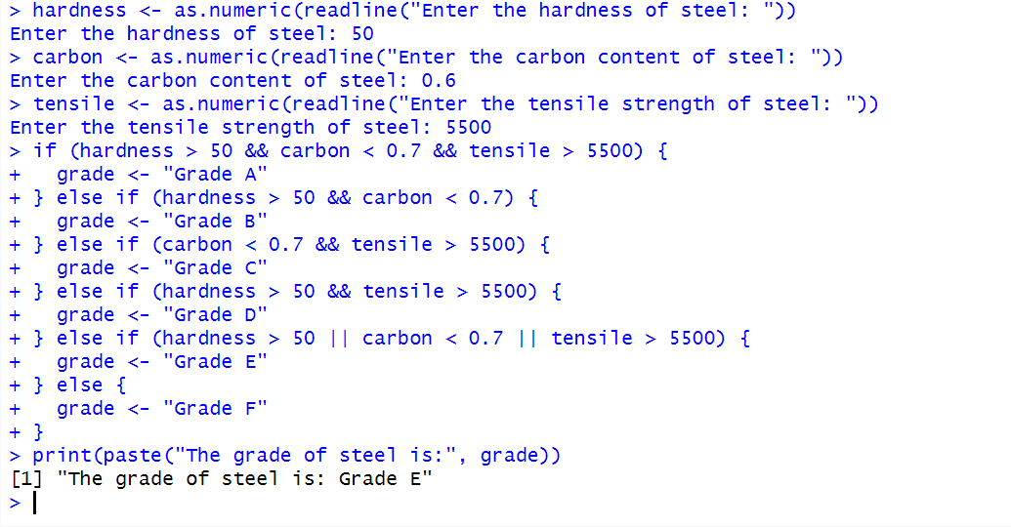

**Observation and Learnings:**

_________________________________________________________________________________________________________________________________________________________________________________________________________________________________________________________________________________________________________________________________________________________________________________________________